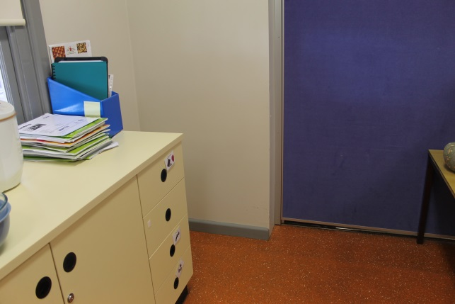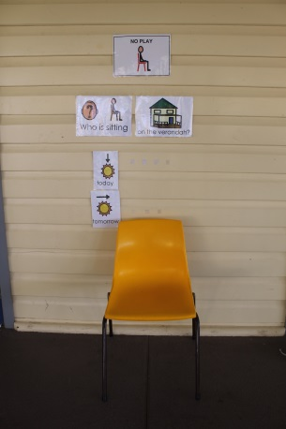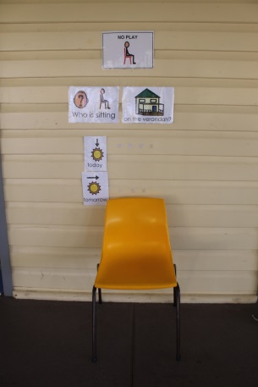

**4**

**THINKING ROOM**

**2**

**Sitting on the verandah**

**3**

**Sitting on the verandah**

**1**

**Sitting on the verandah**