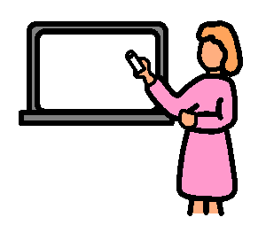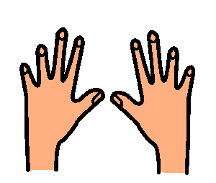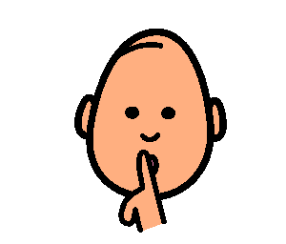

**Listen to**

**Teacher**

**Hands to**

**Yourself**

**Quiet**

**Voice**

**Class Rules**