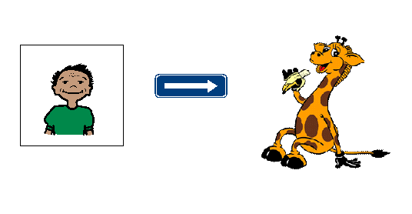
Eddy is going to visit Healthy Harold.
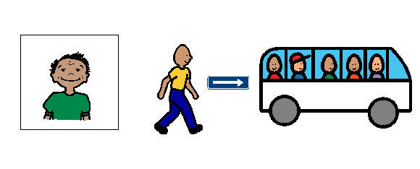

Eddy is going to walk quietly to the bus.
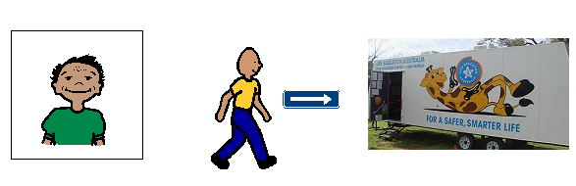

Eddy is going to get off the bus and
Walk to the Healthy Harold van.

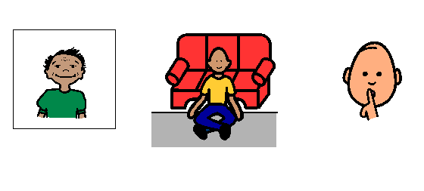Eddy is going to sit quietly and listen.

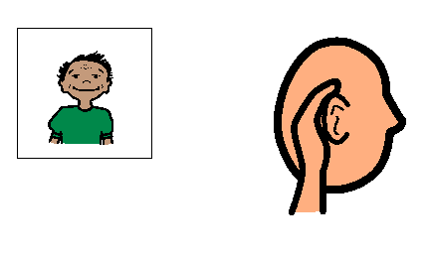
Eddy is going to listen to Paula.
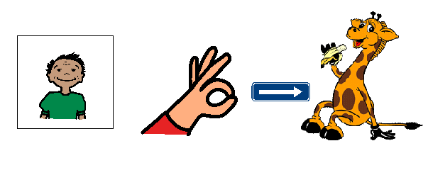
If Eddy is good he will
Get to see Healthy Harold.
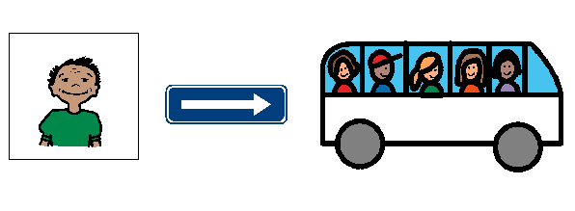

When Healthy Harold has finished
Eddy will walk quietly to the bus.
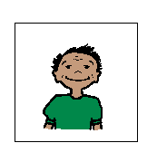

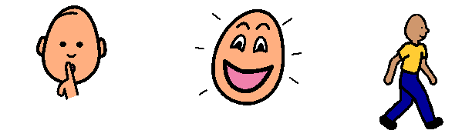
Eddy will be quiet Eddy will be happy Eddy will walk
at Healthy Harold. at Healthy Harold. at Healthy Harold.

