Behaviour Support Plan Information Collection Kit

Person’s Name: | Date:
Person completing form: | Relationship with student:
Other people who contributed to form:

Section One: Information on triggers to behaviour
Some examples of triggers may include: (Circle those that are relevant)
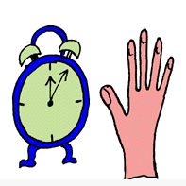  waiting | 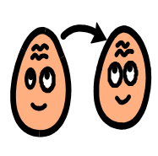  change in people or routine |   very hot or cold foods/ drinks |   not getting what he wants | 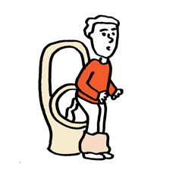  constipation or diarrhoea |   confusion/ unsure what is happening | 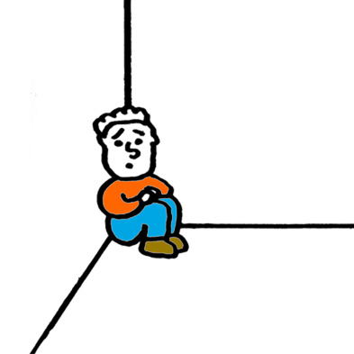  wants to be alone | 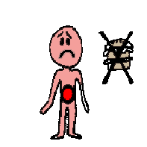  feeling  hungry |   bored

Please list some of the triggers that may lead to the person exhibiting challenging behaviours.

Biological (Within the person) eg tiredness, hunger, thirst, sickness, anticipation of pleasant/ unpleasant events, obsessions, sensory stimulation
The environment (the physical environment) eg
Noise, light, smells, change, enclosed spaces, indoors, outdoors, time of the day,
Sociocultural (the people environment) eg
Absence, presence of certain people, group situations, if someone is getting in trouble
Communication: eg Person not understanding a message someone is telling them, person not conveying a message eg ‘I want’ or “I don’t want’
Section Two: The phases of the behaviour
NOTE: Not all behaviours escalate, but often people who know the person well can see signs of escalating
Some examples of the first phase may include: (circle any behaviours that are relevant)
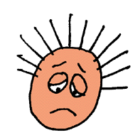  look anxious | 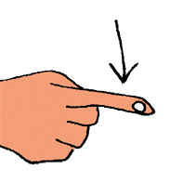  point | 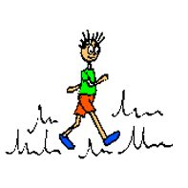  pace the area | 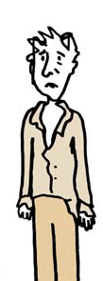  look dishevelled |   say “Go away” | 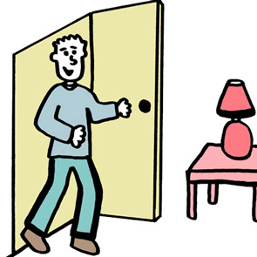  move close to staff

Please list some initial behaviours the person may display:

Some examples of the second phase may include:

  vocalise loudly |   hit objects/ furniture | 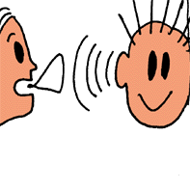  not listening | 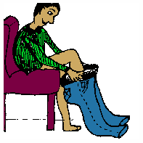  take clothes off | 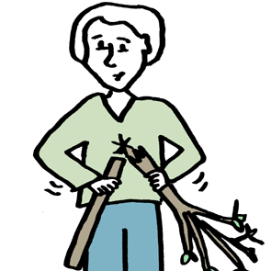  throwing and breaking things | 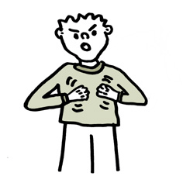  hit her/ himself

Please list some secondary behaviours the person may display:

Some examples of the third phase of the behaviour may include:

  break a window | 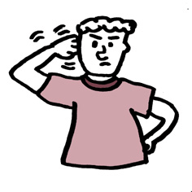  hit head hard | 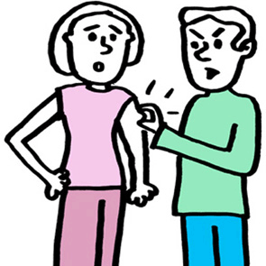  scratch others | 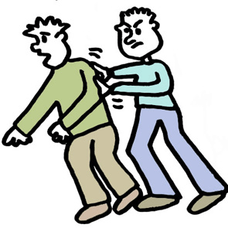  lunge at people | 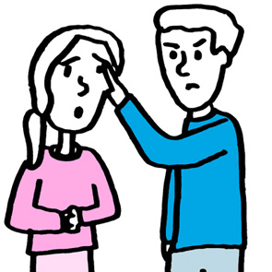  pull other’s hair | 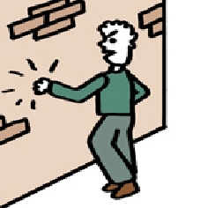  banging walls

Please list the behaviours the person may display in phase three:

Section Three: Understanding the behaviour (from phase three)
Please describe the behaviour of concern: (Eg what exactly the person does during the most serious phase of the behaviour)

How often does the person exhibit the behaviour of concern?

How long does the behaviour of concern last?

How serious/ disruptive is the behaviour of concern?

Section Four: Effective Strategies

Some examples of effective strategies to stop or minimise the behaviour may include:

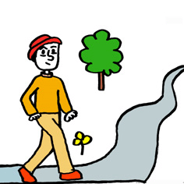  offer a quiet walk |   show person her/ his schedule |   one person only communicating with person |   speak in short sentences |   tell person what to do, NOT what not to do | 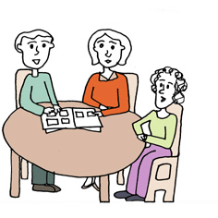  offer person a chat | 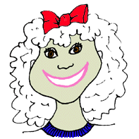  speak in a calm tone
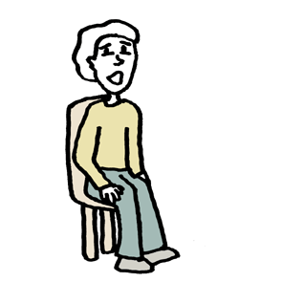  keep person safe- tell them to sit down | 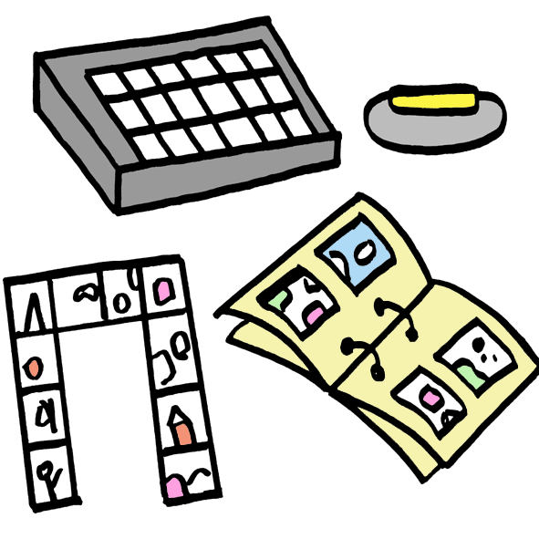  continue to offer person a choice | 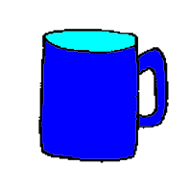  remove dangerous/ throwable items | 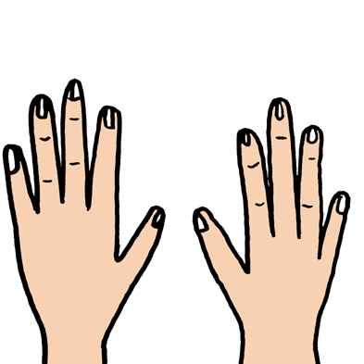  give person something to hold that is soft | keep a safe distance | 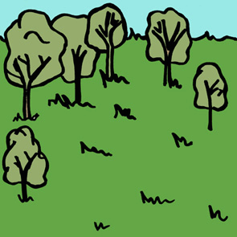  give person some quiet time | 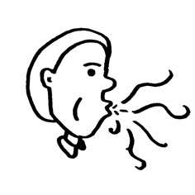  breathing/ relaxation program

List some of the strategies that are effective in assisting the person to minimise / stop the behaviour of concern:

Phase One
Phase two
Phase Three
Thankyou for your time in completing this form.

